**A Comprehensive Analysis of Financial Performance: Insights from a Leading Banks**

**INTRODUCTION**

**1.1 OVERVIEW**

The banking industry world-wide is being transformed. The global forces for change include technological innovation; the deregulation of financial services at the national level and opening-up to international competition; and - equally important - changes in corporate behavior, such as growing disintermediation and increased emphasis on shareholder value. In addition, recent banking crises in Asia and Latin America have accentuated these pressures. The banking industries in central Europe and Latin America have also been transformed as a result of privatizations of state-owned banks that had dominated their banking systems in the past. In this project we are trying to analysis the bank related data and able to extract some insights from the data using Business Intelligence tools. To Extract the Insights from the data and put the data in the form of visualizations, Dashboards and Story we employed Tableau tool.

**1.2 PURPOSE**

Organizations can leverage data analytics to do everything, from learning more about their customers and improving existing processes, to building predictive models and forecasting growth opportunities. Data analytics is a relatively broad term, one that encompasses many different forms of analysis, such as customer analytics, business analytics, predictive analytics, and so on. To that end, banking analytics simply refers to any application of data analytics in banking. Analytics can be used to identify and rate individual customers who are at risk of fraud and then apply different levels of monitoring and verification to those accounts.

**PROBLEM DEFINITION**

The business requirements for analyzing the performance and efficiency of banks in world include identifying KPIs, comparing performance across different countries and states, identifying patterns and trends over time, identifying affecting factors, creating interactive dashboards and reports, identifying areas for improvement, making data-driven decisions, comparing to the industry average and creating forecasting models for future performance. The ultimate goal is to gain insights and improve performance through data visualization techniques.

**RESULT**

# 

# 

# 

# 

# 

# 

# 

# DASHBOARD

# 

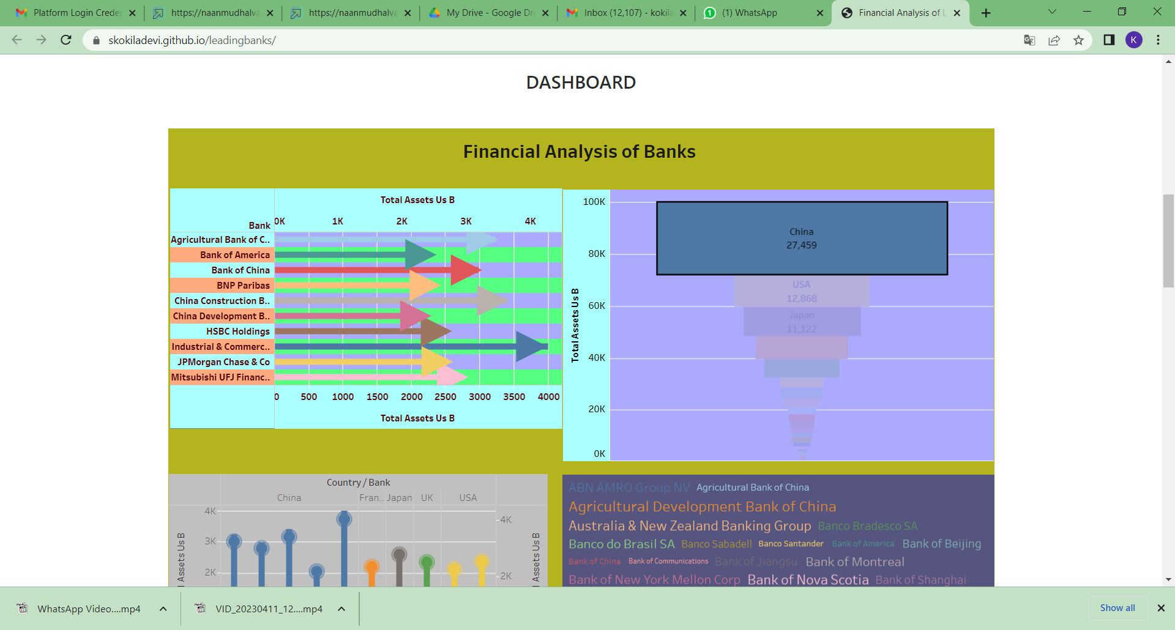

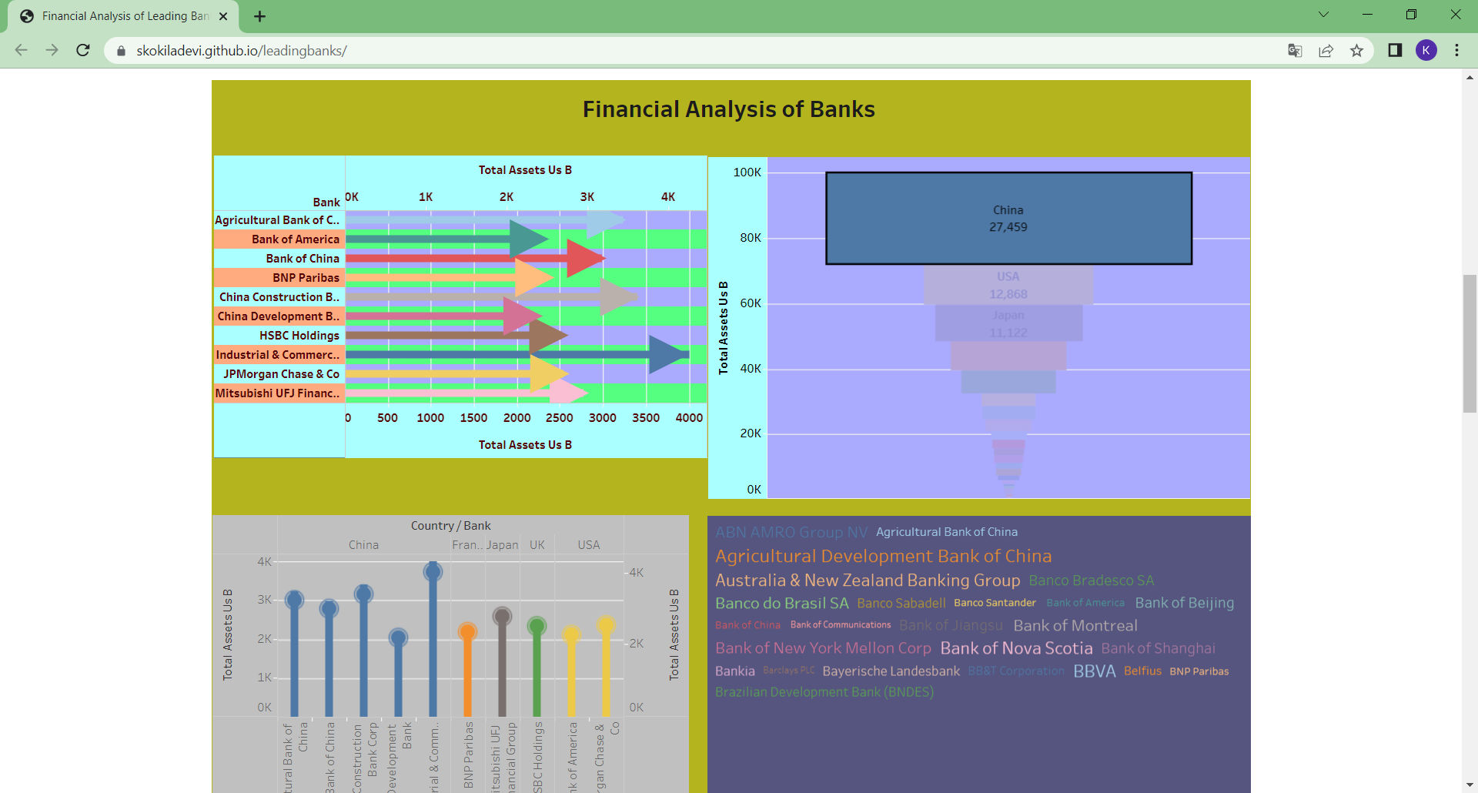

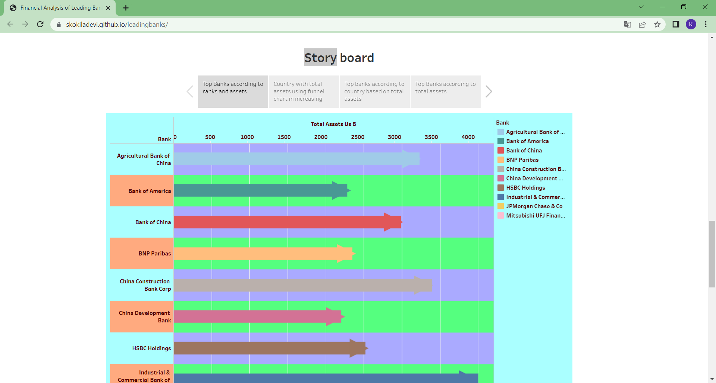

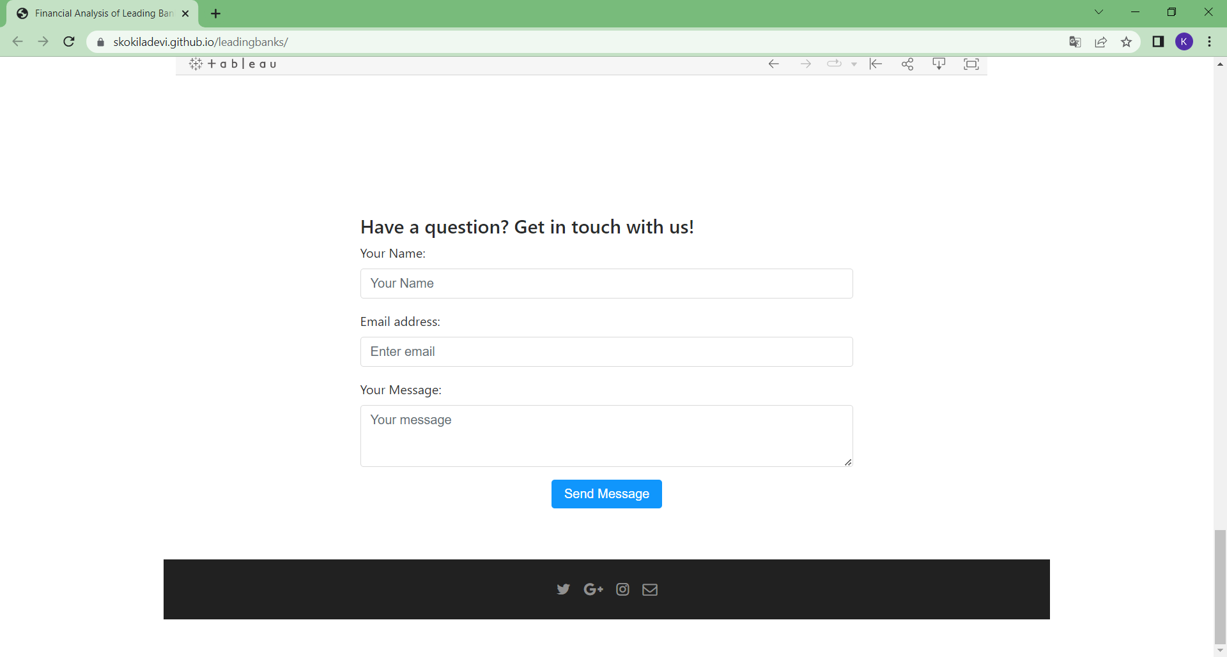

**ADVANTAGES**

* BI also gives banks up-to-date information on their most profitable customers and the banking choices they make. Banks can use that information to retain high-value customers, market the right products to them and decide which products to invest in for the greatest return.
* Looking at past internal and external data, banks can plan for the future. BI can help them spot patterns, address issues going forward and set goals that improve upon historic metrics.
* Using graphs, charts and animation, customizable interfaces help users visualize data. Managers can run queries and pull reports based on their needs. They can analyze the percentage of loans by type, monthly operating expenses or profit and loss by region.
* It detects and correct the errors from data sets with the help of data cleansing. This helps in improving quality of data and consecutively benefits both customers and institutions such as banks, insurance and finance companies.
* It removes duplicate informations from data sets and hence saves large amount of memory space. This decreases cost to the company.

**DISADVANTAGES**

* This may breach privacy of the customers as their information such as purchases, online transactions, subscriptions are visible to their parent companies. The companies may exchange these useful customer databases for their mutual benefits.
* The cost of data analytics tools vary based on applications and features supported. Moreover some of the data analytics tools are complex to use and require training. This increases cost to the company willing to adopt data analytics tools or softwares.
* The information obtained using data analytics can also be misused against group of people of certain country or community or caste.
* It is very difficult to select the right data analytics tools. This is due to the fact that it requires knowledge of the tools and their accuracy in analysing the relevant data as per applications. This increases time and cost to the company.

**APPLICATIONS**

Risk Assessment is one of the top applications of predictive analytics in banking. It is of a high priority to banks as it helps in regulating the financial activities and pricing financial investments. The financial health of a client organization can be assessed for better financing, facilitating acquisitions and mergers, and for investment purposes. Moreover, top banks like JP Morgan Chase and the U.S. Bank already use it consistently to make accurate investment-related decisions.

The traditional credit risk process is slow and labour-intensive, while data-driven predictive models provide instant results. These models use a broader range of data sources and result in a lower rate of default losses, reducing the risk of losing customers to the competitors due to a slow process. Moreover, banks can also find patterns with their customers that can lead to anticipating and mitigating an upcoming risk.

**CONCLUSION**

Most of us have a trustworthy relationship with our banks and financial institutions. Our relationships with banks are built on trust, loyalty, and personal service. However, the increasing sophistication of banking services and products has fueled the need for effective decision-making tools to enable better decisions from data insights.

**APPENDIX**

**<!DOCTYPE html>**

**<html lang="en" >**

**<head>**

**<meta charset="UTF-8">**

**<title>A Comprehensive Analysis of Financial Performance: Insights from a Leading Banks</title>**

**<meta name="viewport" content="width=device-width, initial-scale=1"><link rel='stylesheet' href='https://cdnjs.cloudflare.com/ajax/libs/twitter-bootstrap/4.0.0-alpha.6/css/bootstrap.min.css'>**

**<link rel='stylesheet' href='https://cdnjs.cloudflare.com/ajax/libs/font-awesome/4.7.0/css/font-awesome.min.css'><link rel="stylesheet" href="./style.css">**

**</head>**

**<body>**

**<!-- partial:index.partial.html -->**

**<div class="wrapper">**

**<section class="hero">**

**<header>**

**<div class="container">**

**<nav class="navbar navbar-light navbar-toggleable-sm">**

**<a href="#" class="navbar-brand mb-0"> LEAD BANKS</a>**

**<button class="navbar-toggler navbar-toggler-right" type="button" data-toggle="collapse" data-target="#headerNav" aria-controls="headerNav" aria-expanded="false" aria-label="Toggle navigation">**

**<span class="navbar-toggler-icon"></span>**

**</button>**

**<div id="headerNav" class="collapse navbar-collapse justify-content-end">**

**<ul class="navbar-nav">**

**<li class="nav-item">**

**<a class="nav-link" href="#sec-about">About</a>**

**</li>**

**<li class="nav-item">**

**<a class="nav-link" href="#sec-pricing">Dashboard</a>**

**</li>**

**<li class="nav-item">**

**<a class="nav-link" href="#sec-testimonials">StoryBoard</a>**

**</li>**

**<li class="nav-item">**

**<a class="nav-link" href="#sec-contact">Contact</a>**

**</li>**

**</ul>**

**</div>**

**</nav>**

**</div>**

**</header>**

**<div class="jumbotron jumbotron-fluid mb-0">**

**<div class="container">**

**<div class="row justify-content-center text-center">**

**<div class="col-md-10 col-lg-6">**

**<h1 class="display-5">A Comprehensive Analysis of Financial Performance: Insights from a**

**Leading Banks</h1>**

**<p class="lead">Insights of data showcasing Financial performance of Leading Banks</p>**

**<p class="lead">**

**<a class="btn btn-primary btn-lg" href="#sec-pricing" role="button">CHECK OUT</a>**

**</p>**

**</div>**

**</div>**

**</div>**

**</div>**

**</section>**

**<section id="sec-about" class="sec-about pt-5 pb-5">**

**<div class="container">**

**<div class="row justify-content-center text-center">**

**<div class="col-md-10 col-lg-8">**

**<h1 class="h4">About us</h1>**

**<p class="mt-4 mb-4">The banking industry world-wide is being transformed. The global forces for change include technological**

**innovation; the deregulation of financial services at the national level and opening-up to international**

**competition; and - equally important - changes in corporate behavior, such as growing disintermediation and**

**increased emphasis on shareholder value. In addition, recent banking crises in Asia and Latin America have**

**accentuated these pressures. The banking industries in central Europe and Latin America have also been**

**transformed as a result of privatizations of state-owned banks that had dominated their banking systems in**

**the past. In this project we are trying to analysis the bank related data and able to extract some insights from**

**the data using Business Intelligence tools. To Extract the Insights from the data and put the data in the form of**

**visualizations, Dashboards and Story we employed Tableau tool.</p>**

**</div>**

**</div>**

**<section id="sec-pricing" class="sec-pricing">**

**<div class="container">**

**<h1 class="h4 mb-5 text-center">DASHBOARD</h1>**

**<div class='tableauPlaceholder' id='viz1680595554689' style='position: relative'><noscript><a href='#'><img alt='Financial Analysis of Banks ' src='https:&#47;&#47;public.tableau.com&#47;static&#47;images&#47;2Q&#47;2QJ5ND943&#47;1_rss.png' style='border: none' /></a></noscript><object class='tableauViz' style='display:none;'><param name='host_url' value='https%3A%2F%2Fpublic.tableau.com%2F' /> <param name='embed_code_version' value='3' /> <param name='path' value='shared&#47;2QJ5ND943' /> <param name='toolbar' value='yes' /><param name='static_image' value='https:&#47;&#47;public.tableau.com&#47;static&#47;images&#47;2Q&#47;2QJ5ND943&#47;1.png' /> <param name='animate_transition' value='yes' /><param name='display_static_image' value='yes' /><param name='display_spinner' value='yes' /><param name='display_overlay' value='yes' /><param name='display_count' value='yes' /><param name='language' value='en-US' /><param name='filter' value='publish=yes' /></object></div> <script type='text/javascript'> var divElement = document.getElementById('viz1680595554689'); var vizElement = divElement.getElementsByTagName('object')[0]; if ( divElement.offsetWidth > 800 ) { vizElement.style.width='100%';vizElement.style.height=(divElement.offsetWidth*0.75)+'px';} else if ( divElement.offsetWidth > 500 ) { vizElement.style.width='100%';vizElement.style.height=(divElement.offsetWidth*0.75)+'px';} else { vizElement.style.width='100%';vizElement.style.height='1277px';} var scriptElement = document.createElement('script'); scriptElement.src = 'https://public.tableau.com/javascripts/api/viz_v1.js'; vizElement.parentNode.insertBefore(scriptElement, vizElement); </script>**

**</div>**

**</section>**

**<section id="sec-testimonials" class="sec-testimonials">**

**<div class="container">**

**<h1 class="h4 mb-5 text-center">STORY BOARD</h1>**

**<div class='tableauPlaceholder' id='viz1680595734781' style='position: relative'><noscript><a href='#'><img alt='Story board ' src='https:&#47;&#47;public.tableau.com&#47;static&#47;images&#47;ba&#47;barchart_16805945163450&#47;Story1&#47;1_rss.png' style='border: none' /></a></noscript><object class='tableauViz' style='display:none;'><param name='host_url' value='https%3A%2F%2Fpublic.tableau.com%2F' /> <param name='embed_code_version' value='3' /> <param name='site_root' value='' /><param name='name' value='barchart_16805945163450&#47;Story1' /><param name='tabs' value='no' /><param name='toolbar' value='yes' /><param name='static_image' value='https:&#47;&#47;public.tableau.com&#47;static&#47;images&#47;ba&#47;barchart_16805945163450&#47;Story1&#47;1.png' /> <param name='animate_transition' value='yes' /><param name='display_static_image' value='yes' /><param name='display_spinner' value='yes' /><param name='display_overlay' value='yes' /><param name='display_count' value='yes' /><param name='language' value='en-US' /><param name='filter' value='publish=yes' /></object></div> <script type='text/javascript'> var divElement = document.getElementById('viz1680595734781'); var vizElement = divElement.getElementsByTagName('object')[0]; vizElement.style.width='1016px';vizElement.style.height='991px'; var scriptElement = document.createElement('script'); scriptElement.src = 'https://public.tableau.com/javascripts/api/viz_v1.js'; vizElement.parentNode.insertBefore(scriptElement, vizElement); </script>**

**</div>**

**</section>**

**<section id="sec-contact" class="sec-contact pt-5 pb-5">**

**<div class="container">**

**<div class="row justify-content-center">**

**<div class="col-md-10 col-lg-7">**

**<h1 class="h4">Have a question? Get in touch with us!</h1>**

**<form action="" method="">**

**<fieldset class="form-group">**

**<label for="formName">Your Name:</label>**

**<input id="formName" class="form-control" type="text" placeholder="Your Name" required>**

**</fieldset>**

**<fieldset class="form-group">**

**<label for="formEmail1">Email address:</label>**

**<input id="formEmail1" class="form-control" type="email" placeholder="Enter email" required>**

**</fieldset>**

**<fieldset class="form-group">**

**<label for="formMessage">Your Message:</label>**

**<textarea id="formMessage" class="form-control" rows="3" placeholder="Your message" required></textarea>**

**</fieldset>**

**<fieldset class="form-group text-center">**

**<button class="btn btn-primary" type="submit">Send Message</button>**

**</fieldset>**

**</form>**

**</div>**

**</div>**

**</div>**

**</section>**

**<footer class="footer">**

**<div class="container">**

**<ul class="list-inline mb-0 text-center">**

**<li class="list-inline-item">**

**<a href=""><span class="fa fa-twitter"></span></a>**

**</li>**

**<li class="list-inline-item">**

**<a href=""><span class="fa fa-google-plus"></span></a>**

**</li>**

**<li class="list-inline-item">**

**<a href=""><span class="fa fa-instagram"></span></a>**

**</li>**

**<li class="list-inline-item">**

**<a href=""><span class="fa fa-envelope-o"></span></a>**

**</li>**

**</ul>**

**</div>**

**</footer>**

**</div>**

**<!-- partial -->**

**<script src='https://cdnjs.cloudflare.com/ajax/libs/jquery/3.2.1/jquery.min.js'></script>**

**<script src='https://cdnjs.cloudflare.com/ajax/libs/twitter-bootstrap/4.0.0-alpha.6/js/bootstrap.min.js'></script><script src="./script.js"></script>**

**</body>**

**</html>**